Global Disease Tracking Database

A Reference Manual for Database Administrators

Doug Strouth

CIS228

10 December 2014

Table of Contents

Summary 3

Table creation 3

Primary Key Sequences 5

Inserting Data into Tables 5

Indexing Tables 6

Common Queries 7

Joining data from multiple tables 10

Selected single row functions 15

Group functions 20

Sub queries 23

Appendix A: Table Constraints 25

Appendix B: Database Sequences and Their Associated Columns 29

Appendix C: Table Indices 30

Appendix D: Table Descriptions 31

Appendix E: Common Simple Queries 37

Appendix F: Full Database Creation Script and All Reference Queries 38

# Summary

This document seeks to outline the structure and common uses of the Global Disease Tracking (GDT) database. The process of creating the database, the data relationships between tables, and the types of queries the database will handle are outlined in order to provide a reliable reference for administrators of the database. DBMs may wish to print or bookmark the appendices for quick reference when providing support.

# Table creation[1]

The tables are organized in six groups in order to facilitate creation with constraints. The tables with zero foreign keys are created first and each group progresses through the tables with the most reliance on previously completed tables.

The groups are as follows:

Group 1

PATIENT

REGION

COUNTRY

DISEASE_TYPE

AFTEREFFECT

CAT_EVENT

SYMPTOM _LIST

Group 2

LOCATION

DISEASE

Group 3

HEALTH_PROFESSION

EXPECTED_SYMPTOM

Group 4

CASE[2]

OUTCOME

Group 5

ENCOUNTER

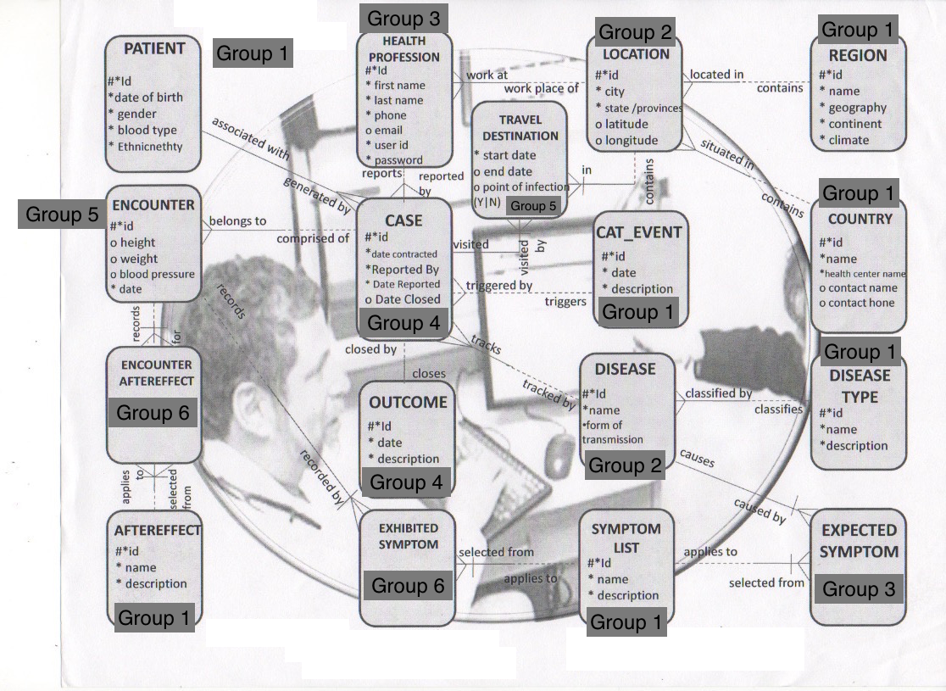TRAVEL_DESTINATION

Group 6

ENCOUNTER_AFTEREFFECT

EXHIBITED_SYMPTOM

Image1- A visual map of the tables and their groups

A complete list of every table, its fields, their types, and the constraint types on each field can be found in Appendix D

A list of the names of each of the constraints can be found in Appendix A. In order to accommodate the length limit in APEX for constraint names some words like location or effect were shortened.

To add a new constraint follow this example:

Ex:

*ALTER TABLE COUNTRY*

*ADD CONSTRAINT COUNTRY_HEALTH_CENTER;*

## Primary Key Sequences[3]

Sequences were created for all of the primary keys of the tables in the database, except the tables consisting only of a composite primary key. All of the sequence values are five digit numbers in order to accommodate a large amount of data incrementing by one, starting with the value 1. The sequences do not have caches since there is global access to the database and number errors could occur and the sequences do not cycle in order to avoid confusion when referencing between tables.

An example of a sequence creation statement and alteration of the sequence definition is given below. The creation statement makes a purposeful mistake in order to show how to alter the sequence in the next statement and removing the cache. A full list of the sequences in the database can be found in Appendix B.

*7A)*

*CREATE SEQUENCE PATIENT_ID_SEQ*

*INCREMENT BY 1*

*START WITH 1*

*CACHE 5*

*NOCYCLE;*

*7B)*

*ALTER SEQUENCE PATIENT_ID_SEQ*

*NOCACHE;*

## Inserting Data into Tables[4]

Insert data into the tables with an insert statement. Any of the insert statements in the database creation script serve as good examples like the one below. Just be sure to when referencing foreign keys that the data they rely upon has already been inserted.

Ex:

*INSERT INTO HEALTH_PROFESSION*

*VALUES(HEALTH_PROFESSION_ID_SEQ.NEXTVAL,2,'DANIELS','MELANIE', '(610)-459-0647', 'MDANIELS@PSYCH.ORG','MDANIELS','HOSPITABLEHOSPITAL');*

To enter data into specific columns in a table be sure to specify the columns before the values statement

Ex:

*INSERT INTO COUNTRY (COUNTRY_ID,NAME, HEALTH_CENTER,CONTACT_NAME)*

*VALUES(COUNTRY_ID_SEQ.NEXTVAL,'AMERICA', 'BATES HOSPITAL','CONSTANCE PETERSEN');*

## Indexing Tables[5]

A B-Tree index was added to the NAME field in the COUNTRY table because names will be a frequent search term.

To add more B-Tree indexes use the following format

Ex:

*8A B-Tree Indexes*

*CREATE INDEX COUNTRY_NAME_IDX*

*ON COUNTRY(NAME);*

A Bitmap index was added to the BLOOD_TYPE field of the PATIENT table because of the limited number of options the field could be.

To add more Bitmap indexes use the following format

Ex:

*8B Bitmap Indexes*

*CREATE BITMAP INDEX PATIENT_BLOOD_TYPE_IDX*

*ON PATIENT(BLOOD_TYPE);*

A function-based index was created on the difference between the DATE_REPORTED and DATE_CONTRACTED in the CASE table because this is an important metric of how quickly diseases are dealt with.

Ex:

*8C Function-based indexes*

*CREATE INDEX CASE_CONTRACT_REPORT_IDX*

*ON CASE(DATE_CONTRACTED - DATE_REPORTED);*

A list of all the indexes in the database can be found in Appendix C.

# Common Queries[6]

This section outlines the extensive functionality of the GDT and its ability to handle complex queries that managers may have to help users troubleshoot. For the simpler queries specifically outlined in the database project outline refer to Appendix E.

The following query allows for the search of patients born within a set time period and ordered in descending order by date of birth and then by gender.

Ex:

*9A WHERE CLAUSE, 9B BETWEEN AND OPERATOR, 11Dd TO_DATE FUNCTION, 9Ga SECONDARY SORT IN ORDER BY CLAUSE*

*SELECT DOB, PATIENT_ID, GENDER, BLOOD_TYPE*

*FROM PATIENT*

*WHERE DOB BETWEEN TO_DATE('JANUARY 01,0060','MONTH DD, YY') AND TO_DATE('DECEMBER 31, 0064','MONTH DD, YY')*

*ORDER BY DOB DESC, GENDER;*

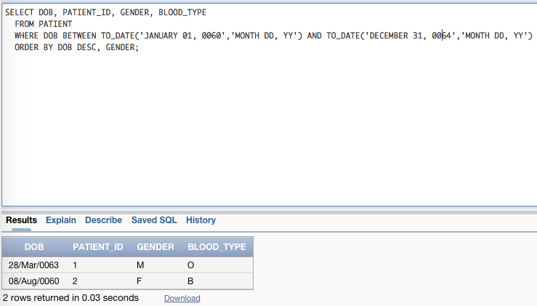

Figure 1

The following query will display patients with a blood type of A or O, or that are female. This could be used to quickly narrow down potential blood donors.

Ex:

*9C IN OPERATOR, 9E LOGICAL OPERATORS, 9Gb ORDER BY SELECT ORDER*

*SELECT PATIENT_ID,BLOOD_TYPE, GENDER*

*FROM PATIENT*

*WHERE BLOOD_TYPE IN ('A','O')*

*OR GENDER='F'*

*ORDER BY 1 DESC;*

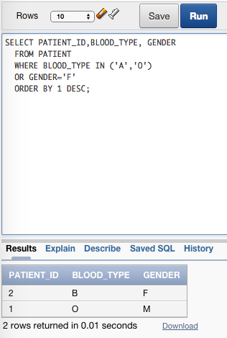

Figure 2

The following query display the full name, user id, and password of a health professional whose last name starts with B. This could come in handy when recovering passwords for doctors who are so tired they can only remember their last names.

Ex:

*9D LIKE OPERATORS, 11Ac INITCAP CASE CONVERSION,11Bh CONCAT FUNCTION*

*SELECT CONCAT(INITCAP(FIRST),CONCAT(' ',INITCAP(LAST))) AS FULL_NAME, USER_ID, PASSWORD*

*FROM HEALTH_PROFESSION*

*WHERE LAST LIKE 'B%';*

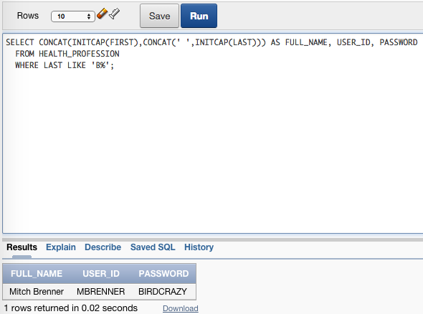

Figure 3

The following query helps quickly identify a list of patients and their disease that have yet to have their cases closed.

Ex:

*9F TREATMENT OF NULL VALUES*

*SELECT PATIENT_ID,DISEASE_ID,DATE_CONTRACTED,REPORTED_BY, DATE_REPORTED*

*FROM CASE*

*WHERE DATE_CLOSED IS NULL;*

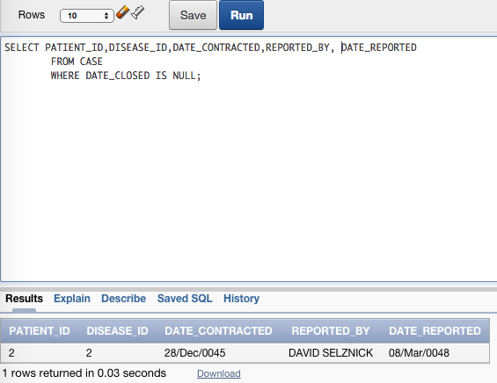

Figure 4

## Joining data from multiple tables[7]

Beyond the simpler queries it will be necessary for users to display information pulled from more than one table. Common types of joins that could be seen are listed below.

A search of patients by country.

Ex:

*10A CARTESIAN JOIN*

*SELECT PATIENT_ID, NAME*

*FROM PATIENT CROSS JOIN COUNTRY;*

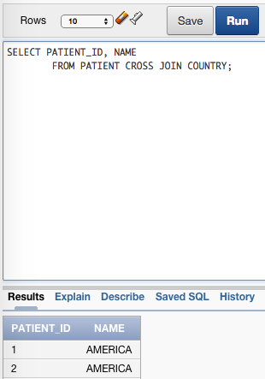

Figure 5

To join and view columns from tables with a common column use an equality join. Using a natural join statement is the easiest way to do this. This one shows the location of patient, their travel destinations, and whether these destinations are points of interest.

Ex:

*10B EQUALITY JOINS*

*SELECT LOCATION_ID, TRAVEL_DESTINATION_ID, POI*

*FROM LOCATION NATURAL JOIN TRAVEL_DESTINATION;*

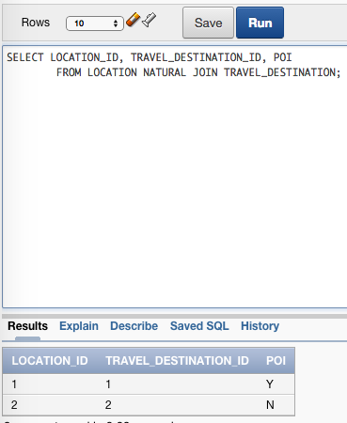

Figure 6

To join columns from tables that do not share a common column use a non-equality join.

Below is an example of a join showing the patient id and their blood pressure.

Ex:

*10C NON-EQUALITY JOIN*

*SELECT PATIENT_ID, BLOOD_PRESSURE*

*FROM PATIENT JOIN ENCOUNTER*

*ON DATE_OF_ENCOUNTER>DOB;*

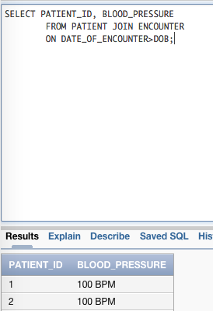

Figure 7

To join a table to itself and find references a self-join is used. They would typically be structured like this example, but this one is not particularly useful due to the limited info in the database at this time. DBAs may find that as tables become more fleshed out this structure may become more useful as patients switch doctors or regions

Ex:

*10D SELF JOIN*

*SELECT h.FIRST, h.LAST, p.LAST*

*FROM HEALTH_PROFESSION h JOIN HEALTH_PROFESSION p*

*ON p.HEALTH_PROFESSION_ID = r.HEALTH_PROFESSION_ID;*

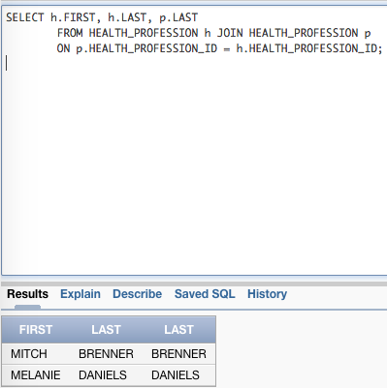

Figure 8

To display results with a null column when there is no matching record in the other table use an outer join. This outer join helps display a list of locations and the full name of the health professionals in the database.

Ex:

*10E FULL OUTER JOIN*

*SELECT LAST, FIRST, LOCATION_ID*

*FROM LOCATION l FULL OUTER JOIN HEALTH_PROFESSION h*

*USING (LOCATION_ID);*

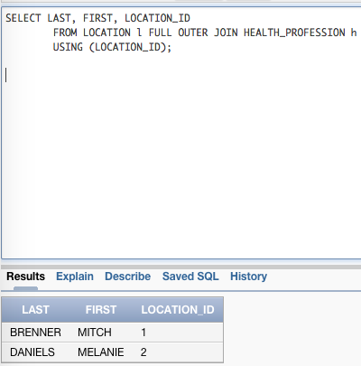

Figure 9

## Selected single row functions[8]

Determine length of a field use the length function. The example given is the length of user passwords and their corresponding user id.

Ex:

*11Bb LENGTH FUNCTION*

*SELECT USER_ID,LENGTH(PASSWORD)*

*FROM HEALTH_PROFESSION;*

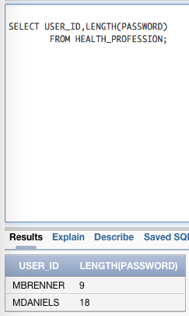

Figure 10

To select only part of a varchar2 field use the substring function. If the first 3 letters of a doctor’s last name were needed for prescription verification this query could be used.

Ex:

*11Ba SUBSTRING FUNCTION*

*SELECT SUBSTR(LAST,1,3)*

*FROM HEALTH_PROFESSION;*

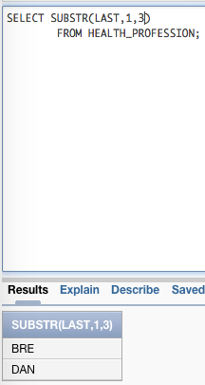

Figure 11

Rounding numbers could also be useful and would take this format.

Ex:

*11Ca ROUND FUNCTION*

*SELECT ROUND(PATIENT_ID, 1)*

*FROM PATIENT;*

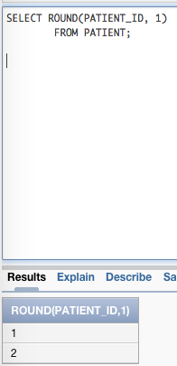

Figure 12

Similarly exponent operations would be entered like thus.

Ex:

*11Ca POWER FUNCTION*

*SELECT POWER(PATIENT_ID, 3)*

*FROM PATIENT;*

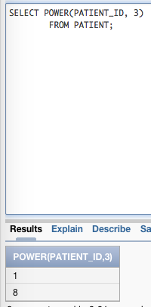

Figure 13

Date measurements are important when figuring out how urgent a case might be. This statement will add 3 months to the contraction date and round it to the last day of the month or a specific day of the week

Ex:

*11Db ADD_MONTHS FUNCTION, 11Dc LAST_DAY AND NEXT_DAY FUNCTION*

*SELECT CASE_ID, PATIENT_ID, DATE_CONTRACTED, LAST_DAY(ADD_MONTHS(DATE_CONTRACTED,3) )"EXPECTED CLOSE DATE"*

*FROM CASE;*

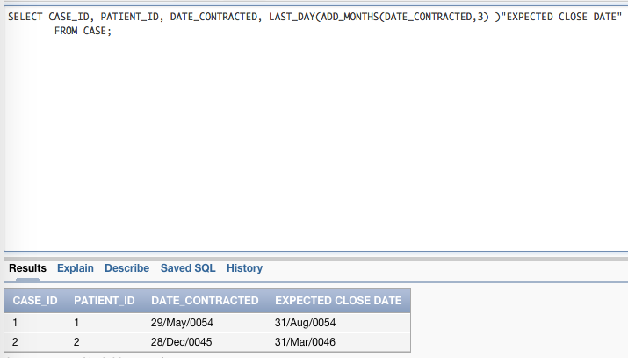

Figure 14

*SELECT CASE_ID, PATIENT_ID, DATE_CONTRACTED, NEXT_DAY(ADD_MONTHS(DATE_CONTRACTED,3), 1 )"EXPECTED CLOSE DATE"*

*FROM CASE;*

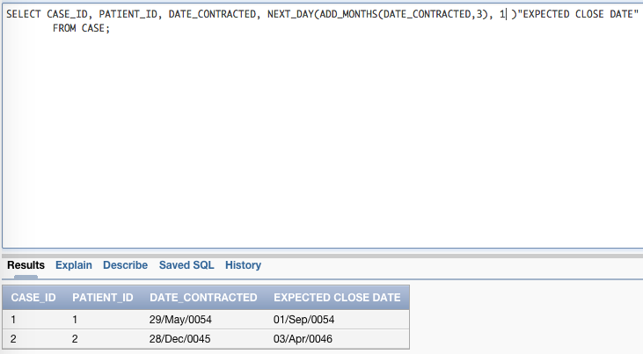

Figure 15

## Group functions[9]

The number of patients in the database could be determined using the next query.

Ex:

*12C COUNT FUNCTION*

*SELECT COUNT(PATIENT_ID) "NUMBER OF PATIENTS"*

*FROM PATIENT;*

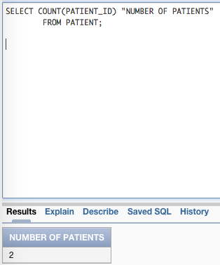

Figure 16

The max or min functions can be used to manipulate numeric data such as patient ids or number of visits

Ex:

*12E MIN FUNCTION, 12D MAX FUNCTION*

*SELECT BLOOD_TYPE, MIN(PATIENT_ID)*

*FROM PATIENT*

*GROUP BY BLOOD_TYPE;*

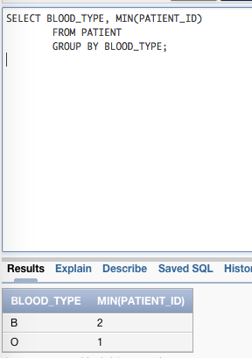

Figure 17

*SELECT BLOOD_TYPE, MAX(PATIENT_ID)*

*FROM PATIENT*

*GROUP BY BLOOD_TYPE;*

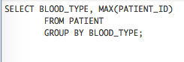

Figure 18

## Sub queries[10]

More advanced users may need help creating single-row or multiple row queries.

To run a single-row sub query use a format like the one below

Ex:

*13A SINGLE-ROW SUB QUERY*

*SELECT BLOOD_TYPE, PATIENT_ID*

*FROM PATIENT*

*WHERE PATIENT_ID=(SELECT MAX(PATIENT_ID)*

*FROM PATIENT);*

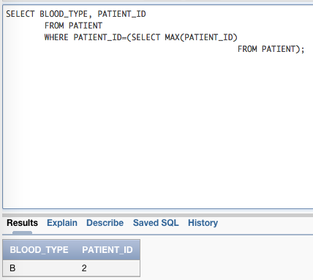

Figure 19

Multiple-row sub queries are a little more complicated. This example will cross-reference all patients and their blood types that are in the patient table and display them if they are also in the case table. Not all patients might have had a case file opened so this quickly narrows down that data.

Ex:

*13B MULTIPLE-ROW SUB QUERY*

*SELECT BLOOD_TYPE, PATIENT_ID*

*FROM PATIENT*

*WHERE PATIENT_ID IN (SELECT PATIENT_ID*

*FROM CASE);*

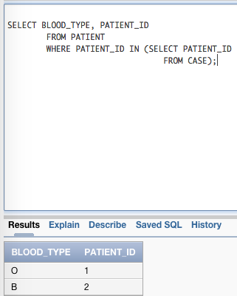

Figure 20

# Appendix A: Table Constraints

|  |  |  |  |  |
| --- | --- | --- | --- | --- |
| **Group** | **Table Name** | **Fields** | **Constraint Type** | **Constraint Name** |
| 1 | PATIENT | PATIENT_ID | PRIMARY KEY | PATIENT_ID_PK |
|  |  | GENDER | CHECK ‘M’, ‘F’ | PATIENT_GENDER_CK |
|  |  |  |  |  |
| 1 | REGION | REGION_ID | PRIMARY KEY | REGION_ID_PK |
|  |  | NAME | UNIQUE, NOT NULL | REGION_NAME_UK |
| 1 | COUNTRY | COUNTRY_ID | PRIMARY KEY | COUNTRY_ID_PK |
|  |  | NAME | UNIQUE, NOT NULL | COUNTRY_NAME_UK |
| 1 | DISEASE_TYPE | DISEASE_TYPE_ID | PRIMARY KEY | DISEASE_TYPE_ID_PK |
| 1 | AFTEREFFECT | AFTEREFFECT_ID | PRIMARY KEY | AFTEREFFECT_ID_PK |
| 1 | CAT_EVENT | CAT_EVENT_ID | PRIMARY KEY | CAT_EVENT_ID_PK |
| 1 | SYMPTOM_LIST | SYMPTOM_ID | PRIMARY KEY | SYMPTOM_LIST_ID_PK |
|  |  |  |  |  |
| 2 | LOCATION | LOCATION_ID | PRIMARY KEY | DISEASE_ID_PK |
|  |  | REGION_ID | FOREIGN KEY | DISEASE_TYPE_ID_FK |
| 2 | DISEASE | DISEASE_ID | PRIMARY KEY | HEALTH_PROFESSION_ID_PK |
|  |  | DISEASE_TYPE_ID | FOREIGN KEY | HEALTH_PROFESSION_LOC_ID_FK |
|  |  |  |  |  |
| 3 | HEALTH_PROFESSION | HEALTH_PROFESSION_ID | PRIMARY KEY | HEALTH_PROFESSION_ID_PK |
|  |  | LOCATION_ID | FOREIGN KEY | HEALTH_PROFESSION_LOC_ID_FK |
|  |  | USER_ID | UNIQUE | HEALTH_PROFESSION_USER_ID_UK |
| 3 | EXPECTED_SYMPTOM | SYMPTOM_ID, DISEASE_ID | PRIMARY KEY | EXPECTED_SYMPTOM_PK |
|  |  | SYMPTOM_ID | FOREIGN KEY | EXPECTED_SYMPTOM_SYMPTOM_ID_FK |
|  |  | DISEASE_ID | FOREIGN KEY | EXPECTED_SYMPTOM_DISEASE_ID_FK |
|  |  |  |  |  |
| 4 | CASE | CASE_ID | PRIMARY KEY | CASE_ID_PK |
|  |  | PATIENT_ID | FOREIGN KEY | CASE_PATIENT_ID_FK |
|  |  | HEALTH_PROFESSION_ID | FOREIGN KEY | CASE_HEALTH_PROFESSION_ID_FK |
|  |  | DISEASE_ID | FOREIGN KEY | CASE_DISEASE_ID_FK |
|  |  | CAT_EVENT_ID | FOREIGN KEY | CASE_CAT_EVEN_ID_FK |
|  |  | OUTCOME_ID | FOREIGN KEY | CASE_OUTCOME_ID_FK |
| 4 | OUTCOME | OUTCOME_ID | PRIMARY KEY | OUTCOME_ID_PK |
|  |  | CASE_ID | FOREIGN KEY | OUTCOME_CASE_ID_FK |
| 5 | ENCOUNTER | ENCOUNTER_ID | PRIMARY KEY | ENCOUNTER_ID_PK |
|  |  | CASE_ID | FOREIGN KEY | ENCOUNTER_CASE_ID_FK |
| 5 | TRAVEL_DESTINATION | TRAVEL_DESTINATION_ID | PRIMARY KEY | TRAVEL_DESTINATION_ID_PK |
|  |  | LOCATION_ID | FOREIGN KEY | TRAVEL_DESTINATION_LOC_ID_FK |
|  |  | POI | CHECK ‘Y’, ’N' | TRAVEL_DESTINATION_POI_CK |
|  |  |  |  |  |
| 6 | ENCOUNTER_AFTEREFFECT | AFTEREFFECT_ID, ENCOUNTER_ID | PRIMARY KEY | ENCOUNTER_AFTEREFFECT_PK |
|  |  | AFTEREFFECT_ID | FOREIGN KEY | ENCOUNTER_AFTEREFFECT_AE_ID_FK |
|  |  | ENCOUNTER_ID | FOREIGN KEY | ENCOUNTER_AFTEREFFECT_E_ID_FK |
| 6 | EXHIBITED_SYMPTOM | SYMPTOM_ID, ENCOUNTER_ID | PRIMARY KEY | EXHIBITED_SYMPTOM_PK |
|  |  | ENCOUNTER_ID | FOREIGN KEY | EXHIBITED_SYMPTOM_E_ID_FK |
|  |  | SYMPTOM_ID | FOREIGN KEY | EXHIBITED_SYMPTOM_S_ID_FK |

# Appendix B: Database Sequences and Their Associated Columns

|  |  |  |  |
| --- | --- | --- | --- |
| **Group** | **Table name** | **Sequence Name** | **Column Using Sequence** |
| 1 | PATIENT | PATIENT_ID_SEQ | PATIENT_ID |
| 1 | REGION | REGION_ID_SEQ | REGION_ID |
| 1 | COUNTRY | COUNTRY_ID_SEQ | COUNTRY_ID |
| 1 | DISEASE_TYPE | DISEASE_TYPE_ID_SEQ | DISEASE_TYPE_ID |
| 1 | AFTEREFFECT | AFTEREFFECT_ID_SEQ | AFTEREFFECT_ID |
| 1 | CAT_EVENT | CAT_EVENT_ID_SEQ | CAT_EVENT_ID |
| 1 | SYMPTOM_LIST | SYMPTOM_LIST_ID_SEQ | SYMPTOM_LIST_ID |
|  |  |  |  |
| 2 | LOCATION | LOCATION_ID_SEQ | LOCATION_ID |
| 2 | DISEASE | DISEASE_ID_SEQ | DISEASE_ID |
|  |  |  |  |
| 3 | HEALTH_PROFESSION | HEALTH_PROFESSION_ID_SEQ | HEALTH_PROFESSION_ID |
|  |  |  |  |
| 4 | CASE | CASE_ID_SEQ | CASE_ID |
| 4 | OUTCOME | OUTCOME_ID_SEQ | OUTCOME_ID |
|  |  |  |  |
| 5 | ENCOUNTER | ENCOUNTER_ID_SEQ | ENCOUNTER_ID |
| 5 | TRAVEL_DESTINATION | TRAVEL_DESTINATION_ID_SEQ | TRAVEL_DESTINATION_ID |

# Appendix C: Table Indices

|  |  |  |  |
| --- | --- | --- | --- |
| **Group** | **Table** | **Index Name** | **Index Type** |
| 1 | PATIENT | PATIENT_ID_IDX | B-Tree |
| 1 | PATIENT | PATIENT_BLOOD_TYPE_IDX | Bitmap |
| 4 | CASE | CASE_CONTRACT_REPORT_IDX | Function-Based |

# Appendix D: Table Descriptions

| **Group** | **Table name** | **Fields** | **Type** | **Constraints[11]** | **Foreign key to which table(s)** |
| --- | --- | --- | --- | --- | --- |
| 1 | PATIENT | PATIENT_ID | NUMBER | PRIMARY KEY [12] | CASE |
|  |  | DOB | DATE | NOT NULL[13] |  |
|  |  | GENDER | CHAR | CHECK ‘M’, ‘F’[14] |  |
|  |  | BLOOD_TYPE | VARCHAR2 | NOT NULL |  |
|  |  | ETHNICITY | VARCHAR2 | NOT NULL |  |
|  |  |  |  |  |  |
| 1 | REGION | REGION_ID | NUMBER | PRIMARY KEY | LOCATION |
|  |  | NAME | VARCHAR2 | UNIQUE, NOT NULL[15] |  |
|  |  | GEOGRAPHY | VARCHAR2 | NOT NULL |  |
|  |  | CONTINENT | VARCHAR2 | NOT NULL |  |
|  |  | CLIMATE | VARCHAR2 | NOT NULL |  |
| 1 | COUNTRY | COUNTRY_ID | NUMBER | PRIMARY KEY | LOCATION |
|  |  | NAME | VARCHAR2 | NOT NULL |  |
|  |  | HEALTH_CENTER | VARCHAR2 | NOT NULL |  |
|  |  | CONTACT_NAME | VARCHAR2 |  |  |
|  |  | CONTACT_PHONE | VARCHAR2 |  |  |
| 1 | DISEASE_TYPE | DISEASE_TYPE_ID | NUMBER | PRIMARY KEY | DISEASE |
|  |  | NAME | VARCHAR2 | NOT NULL |  |
|  |  | DESCRIPTION | VARCHAR2 | NOT NULL |  |
| 1 | AFTEREFFECT | AFTEREFFECT_ID | NUMBER | PRIMARY KEY | ENCOUNTER_AFTEREFFECT |
|  |  | NAME | VARCHAR2 | NOT NULL |  |
|  |  | DESCRIPTION | VARCHAR2 | NOT NULL |  |
| 1 | CAT_EVENT | CAT_EVENT_ID | NUMBER | PRIMARY KEY | CASE |
|  |  | DATE_OF_EVENT | DATE | NOT NULL |  |
|  |  | DESCRIPTION | VARCHAR2 | NOT NULL |  |
| 1 | SYMPTOM_LIST | SYMPTOM_ID | NUMBER | PRIMARY KEY | EXPECTED_SYMPTOM, EXHIBITED_SYMPTOM |
|  |  | NAME | VARCHAR2 | NOT NULL |  |
|  |  | DESCRIPTION | VARCHAR2 | NOT NULL |  |
|  |  |  |  |  |  |
| 2 | LOCATION | LOCATION_ID | NUMBER | PRIMARY KEY | HEALTH_PROFESSION, TRAVEL_DESTINATION |
|  |  | REGION_ID | NUMBER | FOREIGN KEY[16] |  |
|  |  | CITY | VARCHAR2 | NOT NULL |  |
|  |  | STATE | CHAR 2 PLACES | NOT NULL |  |
|  |  | LATITUDE | VARCHAR2 |  |  |
|  |  | LONGITUDE | VARCHAR2 |  |  |
| 2 | DISEASE | DISEASE_ID | NUMBER | PRIMARY KEY | CASE, EXPECTED_SYMPTOM |
|  |  | DISEASE_TYPE_ID | NUMBER | FOREIGN KEY |  |
|  |  | NAME | VARCHAR2 | NOT NULL |  |
|  |  | TRANSMISSION_FORM | VARCHAR2 |  |  |
|  |  |  |  |  |  |
| 3 | HEALTH_PROFESSION | HEALTH_PROFESSION_ID | NUMBER | PRIMARY KEY | CASE |
|  |  | LOCATION_ID | NUMBER | FOREIGN KEY |  |
|  |  | LAST | VARCHAR2 | NOT NULL |  |
|  |  | FIRST | VARCHAR2 | NOT NULL |  |
|  |  | PHONE | VARCHAR2 | NOT NULL |  |
|  |  | EMAIL | VARCHAR2 |  |  |
|  |  | USER_ID | VARCHAR2 | UNIQUE |  |
|  |  | PASSWORD | VARCHAR2 |  |  |
| 3 | EXPECTED_SYMPTOM |  |  |  |  |
|  |  | SYMPTOM_ID | NUMBER | PRIMARY KEY |  |
|  |  | DISEASE_ID | NUMBER | PRIMARY KEY |  |
|  |  |  |  |  |  |
| 4 | CASE | CASE_ID | NUMBER | PRIMARY KEY | TRAVEL_DESTINATION |
|  |  | PATIENT_ID | NUMBER | FOREIGN KEY |  |
|  |  | HEALTH_PROFESSION_ID | NUMBER | FOREIGN KEY |  |
|  |  | DISEASE_ID | NUMBER | FOREIGN KEY |  |
|  |  | CAT_EVENT_ID | NUMBER | FOREIGN KEY |  |
|  |  | DATE_CONTRACTED | DATE | NOT NULL |  |
|  |  | REPORTED_BY | VARCHAR2 | NOT NULL |  |
|  |  | DATE_REPORTED | DATE | NOT NULL |  |
|  |  | BETWEEN_CONTRACTION_AND_REPORT[17] |  |  |  |
|  |  | DATE_CLOSED | DATE |  |  |
|  |  | OUTCOME_ID | NUMBER | FOREIGN KEY |  |
| 4 | OUTCOME | OUTCOME_ID | NUMBER | PRIMARY KEY | CASE |
|  |  | CASE_ID | NUMBER | FOREIGN KEY |  |
|  |  | DATE_OF_OUTCOME | DATE | NOT NULL |  |
|  |  | DESCRIPTION | VARCHAR2 | NOT NULL |  |
|  |  |  |  |  |  |
| 5 | ENCOUNTER | ENCOUNTER_ID | NUMBER | PRIMARY KEY | ENCOUNTER_AFTEREFFECT |
|  |  | CASE_ID | NUMBER | FOREIGN KEY |  |
|  |  | HEIGHT | VARCHAR2 |  |  |
|  |  | WEIGHT | NUMBER |  |  |
|  |  | BLOOD_PRESSURE | VARCHAR2 |  |  |
|  |  | DATE_OF_ENCOUNTER | DATE | NOT NULL |  |
| 5 | TRAVEL_DESTINATION | TRAVEL_DESTINATION_ID | NUMBER | PRIMARY KEY |  |
|  |  | LOCATION_ID | NUMBER | FOREIGN KEY |  |
|  |  | START_DATE | DATE | NOT NULL |  |
|  |  | END_DATE | DATE |  |  |
|  |  | POI | CHAR | CHECK ‘Y’, ’N' |  |
|  |  |  |  |  |  |
| 6 | ENCOUNTER_AFTEREFFECT |  |  |  |  |
|  |  | AFTEREFFECT_ID | NUMBER | PRIMARY KEY |  |
|  |  | ENCOUNTER_ID | NUMBER | PRIMARY KEY |  |
| 6 | EXHIBITED_SYMPTOM |  |  |  |  |
|  |  | ENCOUNTER_ID | NUMBER | PRIMARY KEY |  |
|  |  | SYMPTOM_ID | NUMBER | PRIMARY KEY |  |

# Appendix E: Common Simple Queries

SELECT PATIENT WITH MULTIPLE DISEASES

*SELECT PATIENT_ID, CASE_ID, DISEASE_ID*

*FROM PATIENT NATURAL JOIN CASE FULL OUTER JOIN DISEASE*

*USING (DISEASE_ID)*

*ORDER BY PATIENT_ID DESC;*

SELECT PATIENTS PER HEALTH PROFESSIONAL GROUPED BY REGION

*SELECT PATIENT_ID, HEALTH_PROFESSION_ID, REGION_ID*

*FROM CASE NATURAL JOIN HEALTH_PROFESSION NATURAL JOIN LOCATION;*

LIST OF DISEASES WITHIN A REGION

*SELECT DISEASE_ID, REGION_ID*

*FROM DISEASE NATURAL JOIN CASE NATURAL JOIN HEALTH_PROFESSION NATURAL JOIN LOCATION*

*ORDER BY REGION_ID;*

LIST OF SYMPTOMS AND RELATED DISEASES

*SELECT SYMPTOM_ID, NAME, DESCRIPTION, DISEASE_ID*

*FROM EXPECTED_SYMPTOM NATURAL JOIN SYMPTOM_LIST;*

# Appendix F: Full Database Creation Script and All Reference Queries

/* RESET TABLE STRUCTURE */

DROP TABLE PATIENT CASCADE CONSTRAINTS;

DROP TABLE REGION CASCADE CONSTRAINTS;

DROP TABLE COUNTRY CASCADE CONSTRAINTS;

DROP TABLE DISEASE_TYPE CASCADE CONSTRAINTS;

DROP TABLE AFTEREFFECT CASCADE CONSTRAINTS;

DROP TABLE CAT_EVENT CASCADE CONSTRAINTS;

DROP TABLE SYMPTOM_LIST CASCADE CONSTRAINTS;

DROP TABLE LOCATION CASCADE CONSTRAINTS;

DROP TABLE DISEASE CASCADE CONSTRAINTS;

DROP TABLE HEALTH_PROFESSION CASCADE CONSTRAINTS;

DROP TABLE EXPECTED_SYMPTOM CASCADE CONSTRAINTS;

DROP TABLE CASE CASCADE CONSTRAINTS;

DROP TABLE OUTCOME CASCADE CONSTRAINTS;

DROP TABLE ENCOUNTER CASCADE CONSTRAINTS;

DROP TABLE TRAVEL_DESTINATION CASCADE CONSTRAINTS;

DROP TABLE ENCOUNTER_AFTEREFFECT CASCADE CONSTRAINTS;

DROP TABLE EXHIBITED_SYMPTOM CASCADE CONSTRAINTS;

/*RESET SEQUENCES*/

DROP SEQUENCE PATIENT_ID_SEQ;

DROP SEQUENCE REGION_ID_SEQ;

DROP SEQUENCE COUNTRY_ID_SEQ;

DROP SEQUENCE DISEASE_TYPE_ID_SEQ;

DROP SEQUENCE AFTEREFFECT_ID_SEQ;

DROP SEQUENCE CAT_EVENT_ID_SEQ;

DROP SEQUENCE SYMPTOM_LIST_ID_SEQ;

DROP SEQUENCE LOCATION_ID_SEQ;

DROP SEQUENCE DISEASE_ID_SEQ;

DROP SEQUENCE HEALTH_PROFESSION_ID_SEQ;

DROP SEQUENCE CASE_ID_SEQ;

DROP SEQUENCE OUTCOME_ID_SEQ;

DROP SEQUENCE ENCOUNTER_ID_SEQ;

DROP SEQUENCE TRAVEL_DESTINATION_ID_SEQ;

/* 1 Table creations */

/* GROUP 1 */

/* 2E NOT NULL CONSTRAINT */

/*2A PRIMARY KEY */

/*2D CHECK CONSTRAINT */

CREATE TABLE PATIENT

(PATIENT_ID NUMBER(5),

DOB DATE NOT NULL,

GENDER CHAR(1) NOT NULL,

BLOOD_TYPE VARCHAR2(5) NOT NULL,

ETHNICITY VARCHAR2(20) NOT NULL,

CONSTRAINT PATIENT_ID_PK PRIMARY KEY (PATIENT_ID),

CONSTRAINT PATIENT_GENDER_CK CHECK (GENDER IN('M','F')));

/* 2C UNIQUE CONSTRAINT */

CREATE TABLE REGION

(REGION_ID NUMBER(5),

NAME VARCHAR2(20) NOT NULL,

GEOGRAPHY VARCHAR2(20) NOT NULL,

CONTINENT VARCHAR2(20) NOT NULL,

CLIMATE VARCHAR2(20) NOT NULL,

CONSTRAINT REGION_ID_PK PRIMARY KEY(REGION_ID),

CONSTRAINT REGION_NAME_UK UNIQUE(NAME)

);

CREATE TABLE COUNTRY

(COUNTRY_ID NUMBER(5),

NAME VARCHAR2(20) NOT NULL,

HEALTH_CENTER VARCHAR2(20) NOT NULL,

CONTACT_NAME VARCHAR2(20),

CONTACT_PHONE VARCHAR2(20),

CONSTRAINT COUNTRY_ID_PK PRIMARY KEY(COUNTRY_ID)

);

CREATE TABLE DISEASE_TYPE

(DISEASE_TYPE_ID NUMBER(5),

NAME VARCHAR2(20) NOT NULL,

DESCRIPTION VARCHAR2(50) NOT NULL,

CONSTRAINT DISEASE_TYPE_ID_PK PRIMARY KEY(DISEASE_TYPE_ID)

);

CREATE TABLE AFTEREFFECT

(AFTEREFFECT_ID NUMBER(5),

NAME VARCHAR2(20) NOT NULL,

DESCRIPTION VARCHAR2(50) NOT NULL,

CONSTRAINT AFTEREFFECT_ID_PK PRIMARY KEY(AFTEREFFECT_ID)

);

CREATE TABLE CAT_EVENT

(CAT_EVENT_ID NUMBER(5),

DATE_OF_EVENT DATE,

DESCRIPTION VARCHAR2(50),

CONSTRAINT CAT_EVENT_ID_PK PRIMARY KEY(CAT_EVENT_ID)

);

CREATE TABLE SYMPTOM_LIST

(SYMPTOM_ID NUMBER(5),

NAME VARCHAR2(20) NOT NULL,

DESCRIPTION VARCHAR2(50) NOT NULL,

CONSTRAINT SYMPTOM_LIST_ID_PK PRIMARY KEY (SYMPTOM_ID)

);

/* GROUP 2 */

/* 2B FOREIGN KEY */

CREATE TABLE LOCATION

( LOCATION_ID NUMBER(5),

REGION_ID NUMBER(5),

CITY VARCHAR2(20) NOT NULL,

STATE CHAR(2) NOT NULL,

LATITUDE VARCHAR2(20),

LONGITUDE VARCHAR2(20),

CONSTRAINT LOCATION_ID_PK PRIMARY KEY (LOCATION_ID),

CONSTRAINT LOCATION_REGION_ID_FK FOREIGN KEY (REGION_ID)

REFERENCES REGION(REGION_ID)

);

CREATE TABLE DISEASE

(DISEASE_ID NUMBER(5),

DISEASE_TYPE_ID NUMBER(5),

NAME VARCHAR2(20) NOT NULL,

TRANSMISSION_FORM VARCHAR2(50),

CONSTRAINT DISEASE_ID_PK PRIMARY KEY (DISEASE_ID),

CONSTRAINT DISEASE_TYPE_ID_FK FOREIGN KEY(DISEASE_TYPE_ID)

REFERENCES DISEASE_TYPE(DISEASE_TYPE_ID)

);

/*GROUP 3 */

CREATE TABLE HEALTH_PROFESSION

(HEALTH_PROFESSION_ID NUMBER(5),

LOCATION_ID NUMBER(5),

LAST VARCHAR2(20) NOT NULL,

FIRST VARCHAR2(20) NOT NULL,

PHONE VARCHAR2(20) NOT NULL,

EMAIL VARCHAR2(20),

USER_ID VARCHAR2(20) NOT NULL,

PASSWORD VARCHAR2(20) NOT NULL,

CONSTRAINT HEALTH_PROFESSION_ID_PK PRIMARY KEY (HEALTH_PROFESSION_ID),

CONSTRAINT HEALTH_PROFESSION_LOC_ID_FK FOREIGN KEY (LOCATION_ID)

REFERENCES LOCATION(LOCATION_ID),

CONSTRAINT HEALTH_PROFESSION_USER_ID_UK UNIQUE(USER_ID)

);

CREATE TABLE EXPECTED_SYMPTOM

(

SYMPTOM_ID NUMBER(5),

DISEASE_ID NUMBER(5),

CONSTRAINT EXPECTED_SYMPTOM_PK PRIMARY KEY (SYMPTOM_ID, DISEASE_ID),

CONSTRAINT EXPECTED_SYMPTOM_SYMPTOM_ID_FK FOREIGN KEY (SYMPTOM_ID)

REFERENCES SYMPTOM_LIST (SYMPTOM_ID),

CONSTRAINT EXPECTED_SYMPTOM_DISEASE_ID_FK FOREIGN KEY (DISEASE_ID)

REFERENCES DISEASE (DISEASE_ID)

);

/*GROUP 4 */

/* 4 HANDLING VIRTUAL COLUMNS */

CREATE TABLE CASE

(CASE_ID NUMBER(5),

PATIENT_ID NUMBER(5),

HEALTH_PROFESSION_ID NUMBER(5),

DISEASE_ID NUMBER(5),

CAT_EVENT_ID NUMBER(5),

DATE_CONTRACTED DATE NOT NULL,

REPORTED_BY VARCHAR2(20) NOT NULL,

DATE_REPORTED DATE NOT NULL,

BETWEEN_CONTRACTION_AND_REPORT AS (DATE_REPORTED - DATE_CONTRACTED),

DATE_CLOSED DATE,

OUTCOME_ID NUMBER(5),

CONSTRAINT CASE_ID_PK PRIMARY KEY (CASE_ID),

CONSTRAINT CASE_PATIENT_ID_FK FOREIGN KEY (PATIENT_ID)

REFERENCES PATIENT(PATIENT_ID),

CONSTRAINT CASE_HEALTH_PROFESSION_ID_FK FOREIGN KEY (HEALTH_PROFESSION_ID)

REFERENCES HEALTH_PROFESSION(HEALTH_PROFESSION_ID),

CONSTRAINT CASE_DISEASE_ID_FK FOREIGN KEY (DISEASE_ID)

REFERENCES DISEASE(DISEASE_ID),

CONSTRAINT CASE_CAT_EVEN_ID_FK FOREIGN KEY (CAT_EVENT_ID)

REFERENCES CAT_EVENT(CAT_EVENT_ID)

);

CREATE TABLE OUTCOME

(OUTCOME_ID NUMBER(5),

CASE_ID NUMBER(5) NOT NULL,

DATE_OF_OUTCOME DATE NOT NULL,

DESCRIPTION VARCHAR2(50),

CONSTRAINT OUTCOME_ID_PK PRIMARY KEY (OUTCOME_ID),

CONSTRAINT OUTCOME_CASE_ID_FK FOREIGN KEY (CASE_ID)

REFERENCES CASE (CASE_ID)

);

/*SPECIAL ENTRY TO ADD OUTCOME_ID AS A FOREIGN KEY TO CASE SINCE THEY WERE MADE SIMULTANEOUSLY */

ALTER TABLE CASE

ADD CONSTRAINT CASE_OUTCOME_ID_FK FOREIGN KEY (OUTCOME_ID)

REFERENCES OUTCOME (OUTCOME_ID);

/* GROUP 5 */

CREATE TABLE ENCOUNTER

(ENCOUNTER_ID NUMBER(5),

CASE_ID NUMBER(5) NOT NULL,

HEIGHT VARCHAR2(20),

WEIGHT VARCHAR2(20),

BLOOD_PRESSURE VARCHAR2(20),

DATE_OF_ENCOUNTER DATE NOT NULL,

CONSTRAINT ENCOUNTER_ID_PK PRIMARY KEY (ENCOUNTER_ID),

CONSTRAINT ENCOUNTER_CASE_ID_FK FOREIGN KEY (CASE_ID)

REFERENCES CASE(CASE_ID)

);

CREATE TABLE TRAVEL_DESTINATION

(TRAVEL_DESTINATION_ID NUMBER(5),

LOCATION_ID NUMBER(5) NOT NULL,

START_DATE DATE NOT NULL,

END_DATE DATE,

POI CHAR(1),

CONSTRAINT TRAVEL_DESTINATION_ID_PK PRIMARY KEY (TRAVEL_DESTINATION_ID),

CONSTRAINT TRAVEL_DESTINATION_LOC_ID_FK FOREIGN KEY (LOCATION_ID)

REFERENCES LOCATION(LOCATION_ID),

CONSTRAINT TRAVEL_DESTINATION_POI_CK CHECK (POI IN ('Y','N'))

);

/*GROUP 6 */

CREATE TABLE ENCOUNTER_AFTEREFFECT

(

AFTEREFFECT_ID NUMBER(5) ,

ENCOUNTER_ID NUMBER(5) ,

CONSTRAINT ENCOUNTER_AFTEREFFECT_ID_PK PRIMARY KEY (AFTEREFFECT_ID, ENCOUNTER_ID),

CONSTRAINT ENCOUNTER_AFTEREFFECT_AE_ID_FK FOREIGN KEY (AFTEREFFECT_ID)

REFERENCES AFTEREFFECT(AFTEREFFECT_ID),

CONSTRAINT ENCOUNTER_AFTEREFFECT_E_ID_FK FOREIGN KEY (ENCOUNTER_ID)

REFERENCES ENCOUNTER(ENCOUNTER_ID)

);

CREATE TABLE EXHIBITED_SYMPTOM

(

ENCOUNTER_ID NUMBER(5) ,

SYMPTOM_ID NUMBER(5),

CONSTRAINT EXHIBITED_SYMPTOM_PK PRIMARY KEY (ENCOUNTER_ID, SYMPTOM_ID),

CONSTRAINT EXHIBITED_SYMPTOM_E_ID_FK FOREIGN KEY (ENCOUNTER_ID)

REFERENCES ENCOUNTER(ENCOUNTER_ID),

CONSTRAINT EXHIBITED_SYMPTOM_S_ID_FK FOREIGN KEY (SYMPTOM_ID)

REFERENCES SYMPTOM_LIST(SYMPTOM_ID)

);

/*PRIMARY KEY SEQUENCE CREATION*/

/* 7A SEQUENCE CREATION */

CREATE SEQUENCE PATIENT_ID_SEQ

INCREMENT BY 1

START WITH 1

CACHE 5

NOCYCLE;

/* 7B ALTERING SEQUENCE */

ALTER SEQUENCE PATIENT_ID_SEQ

NOCACHE;

/*ALL OTHER SEQUENCE CREATIONS */

CREATE SEQUENCE REGION_ID_SEQ

INCREMENT BY 1

START WITH 1

NOCACHE

NOCYCLE;

CREATE SEQUENCE COUNTRY_ID_SEQ

INCREMENT BY 1

START WITH 1

NOCACHE

NOCYCLE;

CREATE SEQUENCE DISEASE_TYPE_ID_SEQ

INCREMENT BY 1

START WITH 1

NOCACHE

NOCYCLE;

CREATE SEQUENCE AFTEREFFECT_ID_SEQ

INCREMENT BY 1

START WITH 1

NOCACHE

NOCYCLE;

CREATE SEQUENCE CAT_EVENT_ID_SEQ

INCREMENT BY 1

START WITH 1

NOCACHE

NOCYCLE;

CREATE SEQUENCE SYMPTOM_LIST_ID_SEQ

INCREMENT BY 1

START WITH 1

NOCACHE

NOCYCLE;

CREATE SEQUENCE LOCATION_ID_SEQ

INCREMENT BY 1

START WITH 1

NOCACHE

NOCYCLE;

CREATE SEQUENCE DISEASE_ID_SEQ

INCREMENT BY 1

START WITH 1

NOCACHE

NOCYCLE;

CREATE SEQUENCE HEALTH_PROFESSION_ID_SEQ

INCREMENT BY 1

START WITH 1

NOCACHE

NOCYCLE;

CREATE SEQUENCE CASE_ID_SEQ

INCREMENT BY 1

START WITH 1

NOCACHE

NOCYCLE;

CREATE SEQUENCE OUTCOME_ID_SEQ

INCREMENT BY 1

START WITH 1

NOCACHE

NOCYCLE;

CREATE SEQUENCE ENCOUNTER_ID_SEQ

INCREMENT BY 1

START WITH 1

NOCACHE

NOCYCLE;

CREATE SEQUENCE TRAVEL_DESTINATION_ID_SEQ

INCREMENT BY 1

START WITH 1

NOCACHE

NOCYCLE;

/* 3 INSERT STATEMENTS */

INSERT INTO PATIENT

VALUES (PATIENT_ID_SEQ.NEXTVAL, '28-MAR-63', 'M','O','RUSSIAN');

INSERT INTO PATIENT

VALUES (PATIENT_ID_SEQ.NEXTVAL, '08-AUG-60', 'F','B','GERMAN');

INSERT INTO PATIENT

VALUES (PATIENT_ID_SEQ.NEXTVAL, '03-MAR-03', 'M','A','ASIAN');

INSERT INTO REGION

VALUES(REGION_ID_SEQ.NEXTVAL,'WEST COAST','WEST','NORTH AMERICA','VARIED');

INSERT INTO REGION

VALUES(REGION_ID_SEQ.NEXTVAL,'DESERT STATES','MIDWEST','NORTH AMERICA','VERY WARM');

INSERT INTO COUNTRY

VALUES(COUNTRY_ID_SEQ.NEXTVAL, 'AMERICA', 'GREEN MANORS ','ANTHONY EDWARDS', '(123)-123-1234');

INSERT INTO COUNTRY (COUNTRY_ID,NAME, HEALTH_CENTER,CONTACT_NAME)

VALUES(COUNTRY_ID_SEQ.NEXTVAL,'AMERICA', 'BATES HOSPITAL','CONSTANCE PETERSEN');

INSERT INTO DISEASE_TYPE

VALUES(DISEASE_TYPE_ID_SEQ.NEXTVAL, 'VIRUS','QUICK INFECTION');

INSERT INTO DISEASE_TYPE

VALUES(DISEASE_TYPE_ID_SEQ.NEXTVAL, 'BRAIN INFECTION', 'INCREASED AGGRESIVENESS');

INSERT INTO AFTEREFFECT

VALUES(AFTEREFFECT_ID_SEQ.NEXTVAL, 'SORES', 'BIG RED, ALL OVER');

INSERT INTO AFTEREFFECT

VALUES(AFTEREFFECT_ID_SEQ.NEXTVAL,'HEADACHE','ONLY ON RT. SIDE');

INSERT INTO CAT_EVENT

VALUES(CAT_EVENT_ID_SEQ.NEXTVAL,'09-MAY-58', 'MASSIVE OUTBREAK');

INSERT INTO CAT_EVENT

VALUES(CAT_EVENT_ID_SEQ.NEXTVAL, '28-JUL-59','ACCIDENTAL DEATH');

INSERT INTO SYMPTOM_LIST

VALUES(SYMPTOM_LIST_ID_SEQ.NEXTVAL, 'STAB WOUNDS', 'POINTED AND ALL OVER');

INSERT INTO SYMPTOM_LIST

VALUES(SYMPTOM_LIST_ID_SEQ.NEXTVAL,'INSANITY','CUCKOO CRAZY');

INSERT INTO LOCATION

VALUES(LOCATION_ID_SEQ.NEXTVAL, 1, 'BODEGA BAY', 'CA', '38.333250','-123.048057');

INSERT INTO LOCATION

VALUES(LOCATION_ID_SEQ.NEXTVAL, 2, 'FAIRVALE','AZ','34.048928','-111.093731');

INSERT INTO DISEASE

VALUES(DISEASE_ID_SEQ.NEXTVAL,1,'BIRD FLU','BIRD ATTACKS');

INSERT INTO DISEASE

VALUES(DISEASE_ID_SEQ.NEXTVAL,2,'HULKISM','BIRD ATTACKS');

INSERT INTO HEALTH_PROFESSION

VALUES(HEALTH_PROFESSION_ID_SEQ.NEXTVAL,1,'BRENNER','MITCH', '(603) 650-5000','MBRENNER@PSYCH.ORG','MBRENNER','BIRDCRAZY');

INSERT INTO HEALTH_PROFESSION

VALUES(HEALTH_PROFESSION_ID_SEQ.NEXTVAL,2,'DANIELS','MELANIE', '(610)-459-0647', 'MDANIELS@PSYCH.ORG','MDANIELS','HOSPITABLEHOSPITAL');

INSERT INTO EXPECTED_SYMPTOM

VALUES(1,1);

INSERT INTO EXPECTED_SYMPTOM

VALUES(2,2);

INSERT INTO CASE(CASE_ID,PATIENT_ID,HEALTH_PROFESSION_ID,DISEASE_ID,CAT_EVENT_ID,DATE_CONTRACTED,REPORTED_BY,DATE_REPORTED,DATE_CLOSED)

VALUES(CASE_ID_SEQ.NEXTVAL,1,1,1,1,'29-MAY-54','HARRY WARNER','29-MAR-63','16-NOV-12');

INSERT INTO CASE(CASE_ID,PATIENT_ID,HEALTH_PROFESSION_ID,DISEASE_ID,CAT_EVENT_ID,DATE_CONTRACTED,REPORTED_BY,DATE_REPORTED)

VALUES(CASE_ID_SEQ.NEXTVAL,2,2,2,2,'28-DEC-45','DAVID SELZNICK','08-MAR-48');

INSERT INTO OUTCOME

VALUES(OUTCOME_ID_SEQ.NEXTVAL,1,'09-SEP-61', 'DESTRUCTION OF TOWN');

/*BECAUSE OF FOREIGN KEY RESTRICTIONS THIS STATEMENT HAD TO BE ADDED AFTER THE INSERT STATEMENT*/

UPDATE CASE

SET OUTCOME_ID=1

WHERE CASE_ID=1;

INSERT INTO ENCOUNTER

VALUES(ENCOUNTER_ID_SEQ.NEXTVAL,1,'6 FT', '180 LBS','100 BPM','22-JUL-64');

INSERT INTO ENCOUNTER

VALUES(ENCOUNTER_ID_SEQ.NEXTVAL,2,'5FT 4IN','115 LBS','85 BPM', '14-JUL-66');

INSERT INTO TRAVEL_DESTINATION

VALUES(TRAVEL_DESTINATION_ID_SEQ.NEXTVAL,1,'1-JUN-56','22-DEC-56','Y');

INSERT INTO TRAVEL_DESTINATION

VALUES(TRAVEL_DESTINATION_ID_SEQ.NEXTVAL,2,'19-DEC-69','21-JUN-72','N');

INSERT INTO ENCOUNTER_AFTEREFFECT

VALUES(1,1);

INSERT INTO ENCOUNTER_AFTEREFFECT

VALUES(2,2);

INSERT INTO EXHIBITED_SYMPTOM

VALUES(1,1);

INSERT INTO EXHIBITED_SYMPTOM

VALUES(2,2);

/* 5 MODIFY EXISTING ROWS */

/* 5A UPDATE COMMAND */

UPDATE PATIENT

SET GENDER='F'

WHERE PATIENT_ID=3;

/* 5B SUBSTITUTION VARIABLES */

/* 6 DELETING ROWS */

DELETE FROM PATIENT

WHERE PATIENT_ID=3;

/* 8 INDEX CREATION */

/* 8A B-TREE */

CREATE INDEX COUNTRY_NAME_IDX

ON COUNTRY(NAME);

/* 8B BITMAP */

CREATE BITMAP INDEX PATIENT_BLOOD_TYPE_IDX

ON PATIENT(BLOOD_TYPE);

/* 8C FUNCTION-BASED */

CREATE INDEX CASE_CONTRACT_REPORT_IDX

ON CASE(DATE_CONTRACTED - DATE_REPORTED);

/*END OF DATABASE CREATION SECTION */

/* 9 QUERIES FOR RESTRICTING ROWS AND SORTING DATA */

/*9A WHERE CLAUSE, 9B BETWEEN AND OPERATOR, 11Dd TO_DATE FUNCTION, 9Ga SECONDARY SORT IN ORDER BY CLAUSE */

SELECT DOB, PATIENT_ID, GENDER, BLOOD_TYPE

FROM PATIENT

WHERE DOB BETWEEN TO_DATE('JANUARY 01, 60','MONTH DD, YY') AND TO_DATE('DECEMBER 31, 64','MONTH DD, YY')

ORDER BY DOB DESC, GENDER;

/* 9C IN OPERATOR, 9E LOGICAL OPERATORS, 9Gb ORDER BY SELECT ORDER*/

SELECT PATIENT_ID,BLOOD_TYPE, GENDER

FROM PATIENT

WHERE BLOOD_TYPE IN ('A','O')

OR GENDER='F'

ORDER BY 1 DESC;

/* 9D LIKE OPERATORS, 11Ac INITCAP CASE CONVERSION,11Bh CONCAT FUNCTION */

SELECT CONCAT(INITCAP(FIRST),CONCAT(' ',INITCAP(LAST))) AS FULL_NAME, USER_ID, PASSWORD

FROM HEALTH_PROFESSION

WHERE LAST LIKE 'B%';

/*9F TREATMENT OF NULL VALUES */

SELECT PATIENT_ID,DISEASE_ID,DATE_CONTRACTED,REPORTED_BY,DATE_REPORTED

FROM CASE

WHERE DATE_CLOSED IS NULL;

/*10A CARTESIAN JOIN */

SELECT PATIENT_ID, NAME

FROM PATIENT CROSS JOIN COUNTRY;

/*10B EQUALITY JOIN */

SELECT LOCATION_ID, TRAVEL_DESTINATION_ID, POI

FROM LOCATION NATURAL JOIN TRAVEL_DESTINATION;

/*10C NON-EQUALITY JOIN */

SELECT PATIENT_ID, BLOOD_PRESSURE

FROM PATIENT JOIN ENCOUNTER

ON DATE_OF_ENCOUNTER>DOB;

/*10D SELF JOIN */

SELECT h.FIRST, h.LAST, p.LAST

FROM HEALTH_PROFESSION h JOIN HEALTH_PROFESSION p

ON p.HEALTH_PROFESSION_ID = h.HEALTH_PROFESSION_ID;

/*10E OUTER JOIN */

SELECT LAST, FIRST, LOCATION_ID

FROM LOCATION l FULL OUTER JOIN HEALTH_PROFESSION h

USING (LOCATION_ID);

/*11Bb LENGTH FUNCTION*/

SELECT USER_ID,LENGTH(PASSWORD)

FROM HEALTH_PROFESSION;

/*11Ba SUBSTRING FUNCTION */

SELECT SUBSTR(LAST,1,3)

FROM HEALTH_PROFESSION;

/* 11Ca ROUND FUNCTION */

SELECT ROUND(PATIENT_ID, 1)

FROM PATIENT;

/* 11Ca POWER FUNCTION */

SELECT POWER(PATIENT_ID, 3)

FROM PATIENT;

/* 11Db ADD_MONTHS FUNCTION, 11Dc LAST_DAY AND NEXT_DAY FUNCTION */

SELECT CASE_ID, PATIENT_ID, DATE_CONTRACTED, LAST_DAY(ADD_MONTHS(DATE_CONTRACTED,3) )"EXPECTED CLOSE DATE"

FROM CASE;

SELECT CASE_ID, PATIENT_ID, DATE_CONTRACTED, NEXT_DAY(ADD_MONTHS(DATE_CONTRACTED,3), MON )"EXPECTED CLOSE DATE"

FROM CASE;

/* 12C COUNT FUNCTION */

SELECT COUNT(PATIENT_ID) "NUMBER OF PATIENTS"

FROM PATIENT;

/* 12E MIN FUNCTION, 12D MAX FUNCTION */

SELECT BLOOD_TYPE, MIN(PATIENT_ID)

FROM PATIENT

GROUP BY BLOOD_TYPE;

SELECT BLOOD_TYPE, MAX(PATIENT_ID)

FROM PATIENT

GROUP BY BLOOD_TYPE;

/*13A SINGLE-ROW SUB QUERY */

SELECT BLOOD_TYPE, PATIENT_ID

FROM PATIENT

WHERE PATIENT_ID=(SELECT MAX(PATIENT_ID)

FROM PATIENT);

/*13B MULTIPLE-ROW SUB QUERY */

SELECT BLOOD_TYPE, PATIENT_ID

FROM PATIENT

WHERE PATIENT_ID IN (SELECT PATIENT_ID

FROM CASE);

/*SELECT PATIENT WITH MULTIPLE DISEASES*/

SELECT PATIENT_ID, CASE_ID, DISEASE_ID

FROM PATIENT NATURAL JOIN CASE FULL OUTER JOIN DISEASE

USING (DISEASE_ID)

ORDER BY PATIENT_ID DESC;

/*SELECT PATIENTS PER HEALTH PROFESSIONAL GROUPED BY REGION */

SELECT PATIENT_ID, HEALTH_PROFESSION_ID, REGION_ID

FROM CASE NATURAL JOIN HEALTH_PROFESSION NATURAL JOIN LOCATION;

/*LIST OF DISEASES WITHIN A REGION */

SELECT DISEASE_ID, REGION_ID

FROM DISEASE NATURAL JOIN CASE NATURAL JOIN HEALTH_PROFESSION NATURAL JOIN LOCATION

ORDER BY REGION_ID;

/*LIST OF SYMPTOMS AND RELATED DISEASES */

SELECT SYMPTOM_ID, NAME, DESCRIPTION, DISEASE_ID

FROM EXPECTED_SYMPTOM NATURAL JOIN SYMPTOM_LIST;

1. This section meets section 1 of the database requirements for full details refer to Appendix D
2. This group also contains an alter statement to add a foreign key to the CASE table since CASE and OUTCOME are linked and so are all the following tables. Adding the foreign key in the CASE creation statement would have returned an error
3. The following section meets section 7 of the database criteria
4. The following section covers section 3 of the database criteria
5. The following section meets section 8 of the database criteria
6. This section meets several criteria requested by the database guidelines. The specific sections are mentioned before the SQL code in every example.
7. The following section primarily meets the requirements of section 10 of the database requirements.
8. The following section primarily meets the requirements of section 11
9. The following section primarily meets the section 12 requirements
10. The following section primarily meets the requirements of section 13
11. The constraint names can be found in Appendix A
12. This meets requirement 2A of the database
13. This meets requirement 2E of the database
14. This meets requirement 2D of the database
15. This meets requirement 2C of the Database
16. This meets requirement 2B of the database
17. This is an example of a virtual column per part 4 of the requirements of the database